**Data Flow Diagrams:**

Project Design Phase-II

Data Flow Diagram & User Stories

|  |  |
| --- | --- |
| Team ID | PNT2022TMID24011 |
| Project Name | Visualising and Predicting Heart Disease with an Interactive Dashboard |
| Maximum Marks | 4 Marks |

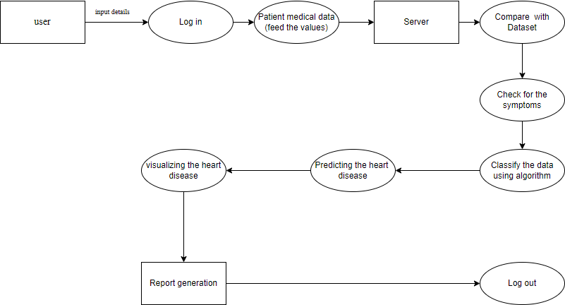

**User Stories**

Use the below template to list all the user stories for the product.

|  |  |  |  |  |  |  |
| --- | --- | --- | --- | --- | --- | --- |
| **User Type** | **Functional Requirement**  **(Epic)** | **User Story Number** | **User Story / Task** | **Acceptance criteria** | **Priority** | **Release** |
| Customer (Mobile user) | Registration | USN-1 | As a user, I can register for the application by  entering my email, password, and confirming my password. | I can access my account / dashboard | High | Sprint-1 |
|  |  | USN-2 | As a user, I will receive confirmation email once I have registered for the application | I can receive confirmation email & click confirm | High | Sprint-1 |
|  |  | USN-3 | As a user, I can register for the application  through Facebook | I can register & access the  dashboard with Facebook Login | Low | Sprint-2 |
|  |  | USN-4 | As a user, I can register for the application through Gmail | I can register through gmail | Medium | Sprint-1 |
|  | Login | USN-5 | As a user, I can log into the application by entering email & password | I can login using mail id and password | High | Sprint-1 |
|  | Dashboard |  |  |  |  |  |
| Customer (Web user) |  | USN-6 | As a user I can fill the details asked here | I can register the asked detail | High | Sprint-1 |
| Customer Care Executive |  | USN-6 | As a user I can execute the give details | I can accept the terms | Medium | Sprint-1 |
| Administrator |  | USN-7 | As a administrator it predict the product | Show the result | High | Sprint-1 |
|  |  |  |  |  |  |  |
|  |  |  |  |  |  |  |
|  |  |  |  |  |  |  |